DEPRESSION ANALYSIS USING COVOLUTIONARY NURAL NETWORKS

**Prof. Dr.R.V.Babar1 Dahale Aashish S2 Shreya Thakur3 Gautam Kumar4**

*Professor, Department of Electronics and Telecommunications, Sinhgad Institute of Technology, Lonavala, India1.*

*Student, Department of Electronics and Telecommunications, Sinhgad Institute of Technology, Lonavala, India234.*

*Sinhgad Institute of Technology, Lonavala, Pune, India*

[dshende.sit@sinhgad.edu1,](mailto:dshende.sit@sinhgad.edu1) [sainathmore192@gmail.com](mailto:sainathmore192@gmail.com) [*,*Sagarrautr@gmail.com](mailto:%2CSagarrautr@gmail.com) [deshmukhkrushna2@gmail.com](mailto:deshmukhkrushna2@gmail.com)

***Abstract : Early detection remains a significant challenge for the treatment of depression. In our work, we proposed a novel approach to mild depression recognition using electroencephalography (EEG). First, we explored abnormal organization in the functional connectivity network of mild depression using graph theory. Second, we proposed a novel classification model for recognizing mild depression. Considering the powerful ability of CNN to process two-dimensional data, we applied CNN separately to the two-dimensional data form of the functional connectivity matrices from five EEG bands (delta, theta, alpha, beta, and gamma). In addition, inspired by recent breakthroughs in the ability of deep recurrent CNNs to classify mental load, we merged the functional connectivity matrices from the three EEG bands that performed the best into a three-channel image to classify mild depression-related and normal EEG signals using the CNN. The results of the graph theory analysis showed that the brain functional network of the mild depression group had a larger characteristic path length and a lower clustering coefficient than the healthy control group, showing deviation from the small-world network. The proposed classification model obtained a classification accuracy of 80.74% for recognizing mild depression. The current study suggests that the combination of a CNN and functional connectivity matrix may provide a promising objective approach for diagnosing mild depression. Deep learning approaches such as this might have the potential to inform clinical practice and aid in research on psychiatric disorders***

**1.INTRODUCTION**

* Electroencephalogram (EEG) is a popular method for diagnosing various neurological diseases. Major Depressive Disorder (MDD) is a mental health disorder that can be diagnosed and treated by making use of EEG.
* G. One of the main challenges in using EEG to accurately identify depression is complexity and variation that exist in the EEG of a depressed person. Manually reading EEG and diagnosing depression is very challenging. An efficient computer aided method can be used for this task. Of the many methods that exists, a deep neural network method called Convolution Neural Networks (CNN) proved to be the most efficient.
* In this a multi-layer deep CNN algorithm is implemented to diagnose depression from EEG of patients. Depression is classified based on a severity index into mild, moderate and major classes. The accuracy, sensitivity and specificity were measured by varying various parameters of the proposed algorithm

## Objectives

* To help doctors in getting correct diagnosis depression from EEG of patients Easily.
* Reduce time of diagnosis

## Electrical Parts and its working: -

The design and implementation stage of the project, involved the raspberry pi board, PC , power supply, EEG report of patient.

Depression is a global public health problem, which has a relatively high lifetime prevalence, ranging from 2 to 15%, and is associated with significant morbidity. According to the latest data from the World Health Organization (2017)[1](https://www.frontiersin.org/articles/10.3389/fnins.2020.00192/full#footnote1), more than 300 million people are now living with depression. Presently, the most widely used methods for depression diagnosis are based on Beck’s Depression Inventory (BDI), the patient’s self-report, the doctor’s clinical experience, or some combination thereof. However, the accuracy of this diagnosis is often influenced by the doctor’s proficiency and patient’s cooperation, both of which are highly subjective. Critically, a subset of depression–mild depression–receives far less attention than does depression, despite being more common than depression and often increasing in severity over time. This lack of attention leads to missed early detection and treatment and increases the mortality risk and likelihood that mild depression will evolve into major depression. Additionally, mild depression is not only a mental illness but also often a social problem. Therefore, studies of methods that might improve the early detection and treatment of mild depression are both necessary and meaningful

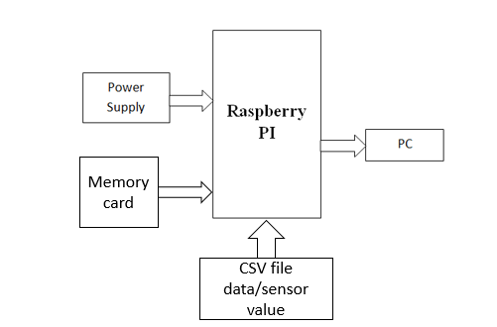

## Fig-Block diagram

**SOFTWARE IMPLEMENTATION**

**Raspberry Pi**

* + Raspberry Pi is the name of a series of single-board computers made by the Raspberry Pi Foundation.
* The Raspberry Pi launched in 2012, and there have been several iterations and variations released since then. The original Pi had a single-core 700MHz CPU and just 256MB RAMA, and the latest model has a quad-core 1.4GHz CPU with 1GB RAM.
* All over the world, people use Raspberry Pi to learn programming skills, build hardware projects, do home automation, and even use them in industrial applications.
* The Raspberry Pi is a very cheap computer that runs Linux, but it also provides a set of GPIO (general purpose input/output) pins that allow you to control electronic components for physical computing and explore the Internet of Things (IoT).

**PYTHON-**

* Python works on different platforms (Windows, Mac, Linux, Raspberry Pi, etc).
* Python has a simple syntax similar to the English language. Python has syntax that allows developers to write programs with fewer lines than some other programming languages.
* Python runs on an interpreter system, meaning that code can be executed as soon as it is written.
* This means that prototyping can be very quick.

Python can be treated in a procedural way, an object-oriented way or a functional way

# Methodology

## Deep learning is a machine learning method that enables

## C:\Users\ADMIN\Downloads\image.png computers to learn by example just like how humans teach themselves.

## Most of the EEG software was found to incorporate some

## form of abnormality detection algorithm.

## A multi-layer deep convolution neural network (CNN) is

## designed and developed to classify depression based on

## severity into three classes: mild, moderate and major.

**RESULT**

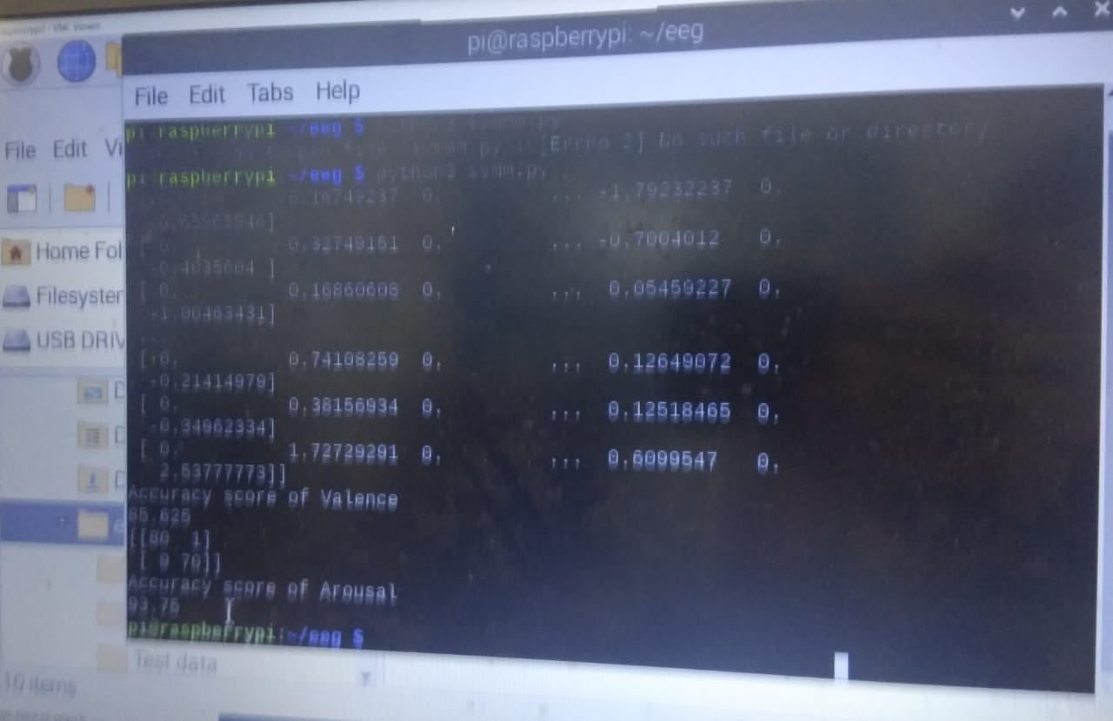

**Conclusion**

* We will get 93 % accuracy from left hemisphere signals and 95% accuracy from right hemisphere of brain at output of our diagnosis
* This observation will get us level of depression
* Depression is classified based on a severity index into mild, moderate and major classes

# Result

# Get accurate diagnosis of depression and display the mental health

# Refrence

* S. C. Liao, C. T. Wu, H. C. Huang, W. T. Cheng, “Major depression detection from EEG signals using kernel eigen-filter-bank common spatial patterns,” Sensors 17 (6) (2017) 1385.
* S. Ghosh-Dastidar, H. Adeli, N. Dadmehr, “Principal component analysis – enhanced cosine radial basis function neural network for robust epilepsy and seizure detection,” IEEE Transactions on Biomedical Engineering 55 (2) (2008) 512-518.
* L. Khedher, L. A. Illan, J. M. Gorriz, J. Ramirez, A. Brahim, A. Meyer-Baese, “Independent component analysis – support vector machine-based computer aided diagnosis system for Alzheimer’s with visual support,” International Journal of Neural Systems 27 (3) (2017) 1650050 (8 pages).
* S. L. Oh, Y. Hagiwara, G. M. Bairy, S. D. Puthankattil, O. Faust, U. C. Niranjan, U. R. Acharya, “Automated diagnosis of depression electroencephalograph signals using linear prediction coding and higher order spectra features,” Journal of Medical Imaging and Health Informatics 7 (8) (2017) 1857-1862.